Solar DC-DC converter.

**Technical requirements**

Rev. 0.1

Revision history

|  |  |
| --- | --- |
| **Revision level** | 0.1 |
| **Release date** | 12-jul-2023 |
| **Status** | Draft |
| **Owner** | Aleksei Z |

|  |  |  |  |
| --- | --- | --- | --- |
| **Version** | **Date** | **Description** | **Originator** |
| 0.1 | 12-jul-2023 | Initial | Aleksei Z |
|  |  |  |  |

List of abbreviations/acronyms

|  |  |
| --- | --- |
| DC | Direct current |
| EMC | Electromagnetic compatibility |
| IP | Ingress protection |
| PCB | Printed circuit board |

1. General requirements
   1. Subject of current requirements is a non-isolated bidirectional DCDC power converter for solar application.
   2. Converter shall have two sets of terminals to connect two solar PV panels in parallel
   3. Converter shall have one set of terminals to connect Li-Ion battery
   4. Converter shall have one set of terminals to connect power inverter
   5. Minimal cost shall be in priority
   6. Interaction with inverter MPPT algorithms is not a subject of current development.
   7. The packaging should be made as an open PCB design with heat sink attached
   8. Context diagram:

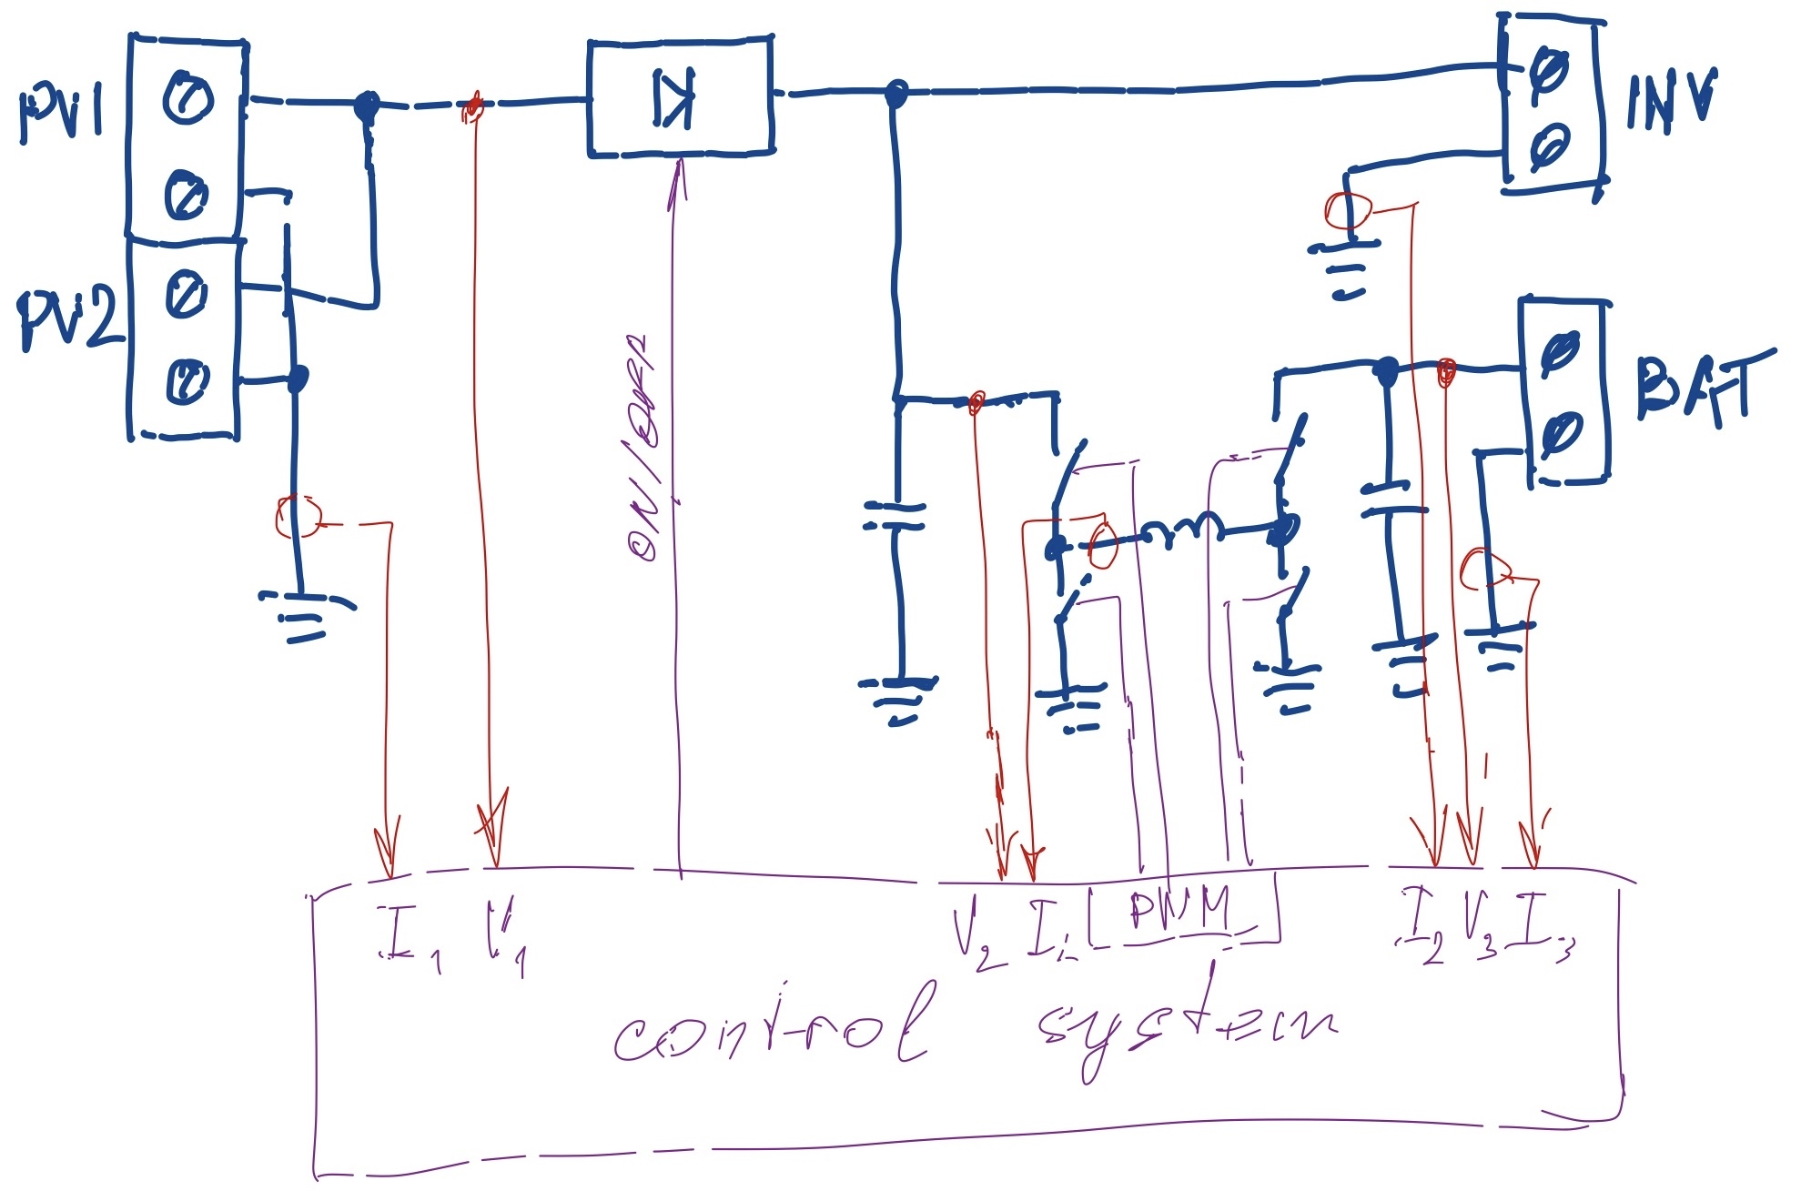

1. Electrical requirements

|  |  |  |  |  |  |
| --- | --- | --- | --- | --- | --- |
| # | **Parameter** | **Min** | **Nom** | **Max** | **Units** |
| AA | Inverter output power |  |  | 900 | W |
| AB | Inverter output current |  |  | 30 | A |
|  | ***2 x Solar panel RSP450D-120*** | | | | |
| A | Output voltage | 24 | 34.7 | 43 | V |
| B | Current total (per panel) |  |  | 26 (13) | A |
|  | ***Li-Ion battery (JB-LFP24-100CC as a reference)*** | | | | |
| C | Battery voltage | 20 | 24 | 26.4 | V |
| D | Battery charge voltage |  | 29 |  | V |
| E | Battery charge current | 1 |  | 30 | A |
|  | ***Power converter set-points*** | | | | |
| F | PV support voltage |  | 34 |  | V |
| G | Short circuit protection delay |  | 500 |  | us |
| H | Battery under/overvoltage protection delay |  | 500 |  | us |
| I | Overcurrent protection delay |  | 1 |  | s |
| J | Overcurrent level |  | 110 |  | % |

1. Environmental requirements
   1. Converter shall operate within temperature range of -30°C to +65°C.
   2. Converter shall have ingress protection not less than IP54 in line with IEC60529.
2. Functional requirements
   * 1. The converter PV input must have “ideal diode” circuitry to prevent reverse current.
   1. The converter must have communication interfaces:
      1. 1 x UART (non-isolated),115 kbps, 8N1, 3.3V-level
      2. 1 x SPI (non-isolated), 1Mbps, 3.3V-level
   2. The converter shall have sufficient modes of operation:
      1. Battery charge automatic mode (solar to battery and solar to inverter power flows)
         1. Control logic shall provide constant voltage with current limit operation (CV/CC)
         2. Voltage and current set-points should be set via communication interface
         3. Charge mode should start automatically if converter is not in IDLE
         4. MPPT tracking of the PV panels should be implemented
         5. Maximum charge power set-point shall be set via communication interface
      2. PV support mode (battery to inverter power node)
         1. The control strategy shall be constant voltage with current limit operation (CV/CC).
         2. Transition to this mode and voltage/current set-points are managed via communication interface.
      3. Converter IDLE mode (Inverter supplied with solar power only)
         1. Transition to IDLE shall be available via communication interface command or by the protection logic.
         2. Only transition via communication interface command to another mode of operation is possible.
   3. The converter shall have protection functionality
      1. Short circuit protection

The control logic shall shutoff the converter in 2.E after short circuit is determined. Protection reset via communication interface shall be implemented.

* + 1. Battery undervoltage protection

Stop discharge if battery voltage reached its minimum value for more than 2.H. No automatic transition to another mode.

* + 1. Battery overvoltage protection

Stop charge if battery voltage goes at least 0.1V above maximum charge voltage level (2.D) during more than 2.H

* + 1. Reverse current to PV panels protection
    2. Overcurrent protection
       1. The converter shall go to IDLE mode if overcurrent level 2.J reached and kept during more than 2.I
       2. Protection reset shall be available via communication interface only

1. Mechanical requirements
   1. All terminals shall be placed along bottom side of the PCB (assumed wall mounted device)
   2. Natural convection only shall be used to cool down
   3. Power stage shall be designed on separated PCB
   4. Cable glands can be used to comply with IP rating